City Forest and Trees

Baltimore City Forest Conservancy District Board
Baltimore, Maryland | 2005

T

ERRIFIC NATIVE TREES FOR CITY AND SUBURBS by Ann Lundy
This spring the Forestry Board will again be selling several native trees that grow well in urban and suburban locations to raise funds for tree plantings at Baltimore City schools. These trees are small in stature when purchased but full of potential for growth when watered regularly! Look for the Forestry Board display at Cylburn Market Day, Flower Mart and other nature and plant oriented events and buy a native tree to green your garden.
The trees offered this spring will include the small but lovely and adaptable Fringe Tree (Chionanthus virginicus), which has fragrant flowers in May and grows in sun or shade. We will also have Dogwoods (Cornus florida and Cornus alternifolia), which bloom in late April and then provide food for migrating birds in the fall when their fruits ripen. Sweetbay Magnolia (Magnolia virginiana), the foundation tree for rare magnolia bogs in Maryland and a fragrant flowering delight all summer when planted in a moist location will be available. It produces red fruits in the fall, which are rapidly devoured by local birds. Our earliest flowering native tree, Serviceberry or Juneberry (Amelanchier sp.), which is a multi-stemmed small tree, has ripe fruit in June for nesting birds and their young families and orange-red fall leaf color. In addition, we will have Black Gum (Nyssa sylvatica), Red Oak (Quercus rubra) and Red Maple (Acer rubrum) for large shade trees - which will provide cooler, fresher air during our Baltimore summers and wonderful fall color or acorns for wildlife.
These are just some of the wonderful trees that are native to Baltimore and its suburbs. There will be other trees available as well so look for them at the Forestry Board booth this spring and take home something beautiful to grow.

HERRING RUN WATERSHED:

AN ACTIVE ASSOCIATION
Darin Crew, the program manager for the Herring Run Watershed Association, and a member of the Baltimore Forestry Board, report that 942 trees were planted last year in the watershed, an area of 45 square miles. Trees were planted at schools and parks. More than 800 people were involved last year in tree planting and in other activities, such as trash cleaning.
Herring Run itself includes about 60 acres east

of York Road and drains to Back River. One of the projects of the association has been showing homeowners the technique of dealing with storm water to make rain gardens.
Volunteers are always welcome to take part in activities in the Herring Run Watershed. Those interested may call Darin Crew: 410-254-1577. His e-mail is: dcrew@herringrun.org The website for the organization is: http://www.herringrun.org/.

STEWARTIA: A GREAT SPECIMEN TREE by Adelaide C. Rackemann
Anyone looking for an unusual and highly decorative tree would do well to plant a Stewartia. This member of the tea family --Theaceae-- named for John Stuart, an18th century patron of botany, is a deciduous tree whose flowers appear in summer.
The flowers are white, solitary and more or less cup-shaped. They appear in the leaf axils or near the end of the shoots. Moreover, they are beautiful, somewhat like the flowers of Franklinia, Gordonia and Camellia, other members of the tea family. There are usually five to six petals with a calyx of sepals and one or two bracts just beneath. The petals are joined at the base and are silky on the outside. The flower has many stamens and five styles.
Fruits of Stewartia are woody capsules. But even without the flowers or fruit, Stewartia is a stunning tree. Its foliage is handsome. Alternate leaves are undivided, toothed and on short petioles. The fall color may be purplish to orange red.
The really great thing about some Stewartias is its bark. Flaky and reminiscent of the sycamore tree, it is much more colorful. So even in winter it is a standout. There are seven species of Stewartia. Some are native to North America, and the others are from China, Japan and Korea. But all are said to be available in our country, and all are hardy in our climate - Zone 7. Stewartia sinensis has flowers that are two inches in diameter and fragrant. Stewartia koreana which is taller --it may grow to forty feet --also has larger flowers, three inches in diameter.
But the species considered the prettiest is Stewartia ovata var.grandiflora, or the Mountain Stewartia, with four-inch wide flowers with purple stamens. This grows

to a height of fifteen feet and is thus one of the smaller species.
The other species of Stewartia are S. malacodendron, a native of the southeastern U.S. that has a more shrub-like habit than the others; S. monadelpha, also known as Tall Stewartia, since it can grow to be seventy-five feet high and S. pseudocamellia, which can grow to be forty feet high and has the most colorful flaking bark.
This is a tree that is not demanding. It should have plenty of sun, but be shaded in the hottest part of the day, and acid soil, which is moist and well drained. It needs no pruning and seems to be free of disease and insect pests. Altogether it is a splendid ornamental tree, which deserves to be more widely planted.

IS A RAIN GARDEN RIGHT FOR YOU?
By Ann Lundy
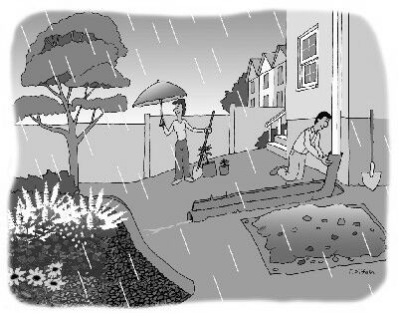
When most of the houses in Baltimore were built people thought that the best way to treat the water that ran off their roofs was to put it in a pipe and run it out to the curb so it could go down the nearest storm drain. Now that we are worried about the pollution that water picks up as it goes down the street (and takes to the Chesapeake Bay), it makes sense to keep as much of that rain water as possible in our yard where it can water our trees and shrubs and be filtered by the soil before it goes into the Bay. The latest term for keeping that roof runoff at home is a rain garden.
I live on a hill and it was easy for me to have my downspouts empty out onto the lawn or onto my trees and shrubs - saving water in my yard rather than letting it run down the storm drain. However, anyone who has a little bit of slope away from their house can capture the water from their roof in a rain garden by making a shallow swale away from the house and planting trees, shrubs, perennials and grasses which will tolerate moist conditions for a day or so after it rains. In addition to giving the water from your roof a place to soak into the ground, it will give you an interesting planting place and allow you to grow plants for birds and other wildlife that will give you pleasure for years to come. And it will help clean up the Chesapeake Bay.
There are a number of useful websites that have information on rain gardens and instructions on how to make them.
Try
http://www.raingardennetwork.com/
http://www.potomacriver.org/arbc/raingardens

BALTIMORE PUBLIC SCHOOLS
GIVEN TREES DURING 2004

Marion Bedingfield head of Tree Planting for Baltimore City and Jeffery Barrett, Grounds Maintenance Supervisor for Baltimore City Schools reported the following plantings: Schools and Nature Center receiving trees from the Forestry Division during 2004 were:
Bragg Nature Center; Barclay Elementary School; Beechfield Elementary School; Cherry Hill Elementary School; Medfileld Height Elementary School; Hampden Elementary School; Edgewood Elementary; Catholic High School; Waverly Elementary School; The Hut School; Frankford Elementary School; Diggs Johnson Middle School; Frederick Douglas High School; Gwynns Falls Elementary School; Thomas Jefferson Elementary School; Holibird Elementary School; Franklin Square Elementary School; Children Guild; Woodhome Elementary School; Stadium School; Sarah Roac Elementary School; Violetville Elementary School; Northern High School; Harbor City High School; James McHenry Elementary School; Sinclair Elementary School; Woodbbourne Day School; City College High School; William S. Baer School; Federal Hill Elementary School; Yorkwood Elementary School; Garrison Middle School; William Pinderhughes Elementary School; Gilmore Elementary School; Dubois High School; Roland Park Elementary School; Lake Clifton High School.
Most planting involved students and volunteers and some sites received up to twelve trees. This is an ongoing program with no cost to the schools. All trees have been donated, thanks to the Baltimore City Forestry Board, Parks and People, and the Department of Natural Resources. For more information contact Jeffery Barrett at: 443- 858- 6226.

Forestry Workshop

Scholarships Available
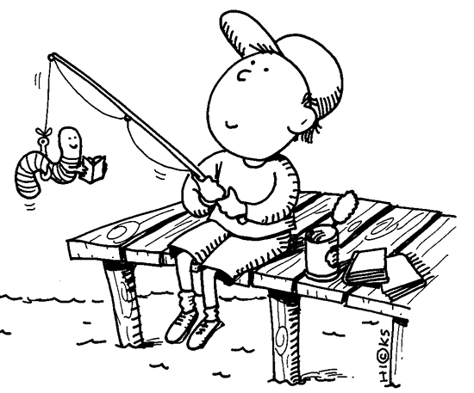
Two scholarships are available for this year’s Forestry and Natural Resources Careers Week Training. The Maryland Association of Forest Conservancy District Boards and the Maryland DNR sponsor the workshop. The Baltimore City Forestry Board will pay the student’s expenses.
The workshop, located at Camp Hickory in Garrett County, will be held July 24 -30, 2005. Two students will be selected from each county and Baltimore City to
represent that area's Forest Conservancy District Board.
Approximately fifteen professional foresters and environmental specialists will lead the 48 students, working in small groups.
The students will have an opportunity to handle technical equipment and participate in tree climbing, water testing, animal tracking, map and compass use and fire control. Contact Sandy Sparks at ssparks@mdo.net for more information.

COMING EVENTS:

Arbor Day -April 27 (Wednesday)
Cylburn Arboretum Free. 9 a.m. to 2:30 a.m. Sponsored by the Baltimore City Forestry Board and the Baltimore Bird Club. Proclamation, presentation and the ceremonial planting of a tree --this year it will be a Chinese pistachio. Any school or other group wishing to take part may call: 410- 367- 2217.

Spring Notable Tree Tour -May 6 (Friday)
Cylburn Arboretum 10 a.m. to 2: 30 p.m. Fee: $25. Includes box lunch. Sponsored by the Forestry Board, aided by Cylburn Arboretum Association. Paid reservations required. For information call: 410 -367- 2217. Marion Bedingfield will lead the tour. There will be stops at Stockton Street and Patterson Park. A unique opportunity to see outstanding trees in Baltimore.

Market Day- May 7 (Saturday)- Cylburn Arboretum
8 a.m. to 2 p.m. Parking fee: $4. A popular annual event at Cylburn Arboretum. Opportunity to buy many kinds of plants - including small trees from the Baltimore City Forestry Board. Come early for best selection!

Flower Mart -May 18 (Wednesday)
Mt. Vernon Square 11 a.m. - 6 p.m. 88th year for this popular event. A chance to buy many kinds of plants, handicrafts and much else - including lemon peppermint sticks. The Forestry Board will have a booth.

Baltimore Herb Festival -May 28 (Saturday)
Leakin Park 10 a.m.-5 p.m Fee: $5. Many vendors specializing in herbs. Also a chance to buy other plants. The Forestry Board will take part.

Maryland State Fair -August 26- September 5 Timonium all day. Admission charges vary.

JFX Celebration - September 18 (Sunday)
Cold Spring Lane at JFX 8 am – 2 pm JFX, northbound lanes, will be closed off to traffic, so people can walk, bike on the expressway. Also canoe races and much more. Vendors will include the Forestry Board.

Festafall -October 8 (Saturday) - Cylburn
10 a.m. -3 p.m. Parking fee: $4. Family activities include hayrides, pumpkin painting, scarecrow building and amaze. Refreshments. Plants for sale.

The Baltimore City Forest Conservancy District Board is an advocacy panel to the Maryland Department of Natural Resources-
Forest Service. The Board:
Richard Edson, Chairman
Russ Moss, Vice Chairman
Tom Green, Treasurer
Meredith P. Millspaugh
Adelaide Rackemann
Elsa Lankford
Associate members:
Gary Letteron
Ann Lundy
Ken Williams
Robert Black
Elspeth Wheeler
Technical Advisors:
Marion Bedingfield, Forestry Division
Department of Recreation and Parks
Pam Kelly, Secretary, Executive Director,
State Association MD DNR-Forest Service
Joe Burch, Forestry Division
Department of Recreation and Parks
Amanda Cunningham, Community Forestry
Parks & People Foundation
Jeffery Barrett - Baltimore City Public School Grounds
Gerard Moudry - Member Emeritus

For more board information, contact Pam Kelly at
410-260-8589

The Baltimore City Forestry Board web page is located at: http://www.baltocfb.sailorsite.net/BCFB.html

