City Forest and Trees

Baltimore City Forest Conservancy District Board
Baltimore, Maryland | 2011

Arbor Day
by Sarah Lord
On Friday April 29 2011, the Baltimore City Forestry Board is pleased to be working with TreeBaltimore, Banner Neighborhoods, and the staff and students of two east Baltimore schools, William Paca elementary and Tench Tilghman middle school. Both are in the McElderry Park neighborhood, which suffers from only 3% tree canopy and high rates of childhood asthma. These plantings of eight trees at each school will additionally inaugurate the Baltimore Tree Trust's McElderry Park Trees for Public Health Project, which will plant 800 trees in the community in the next few years.
Also partnering with us are the McElderry Park Community Association, Amazing Grace Evangelical Lutheran Church, Chesapeake Habitat for Humanity, Johns Hopkins Center for Urban Environmental Health, the Environmental Justice Partnership, Inc., and others. Students participating in the tree plantings can earn a MD Forest Service Junior Forest Ranger Patch. As 2011 is The International Year of the Forest, educating students about Baltimore's need to double its tree canopy seems particularly relevant. An international poster contest is open to 5th graders.

Urban Tree Facts:
Trees are the lungs of the city. A healthy "urban forest" provides important benefits by
1. Cleaning our air, helping us breathe
2. Making communities more attractive
3. Quieting the city's traffic noises
4. Keeping the temperature cooler in the hot summer months
5. Reducing the amount of rainwater going down storm drains

6. Helping keep pollutants out of the bay
7. Giving birds and squirrels a place to nest and feed
Young trees need water! With your neighbors, help
trees survive by watering twice a week.

Neighbors plant trees, good feelings in East Baltimore,


Patterson Park residents add 27 saplings to nearly treeless block (December 11, 2010 by Timothy B. Wheeler, The Baltimore Sun
Full of hope for a greener new year, dozens of neighbors near Patterson Park turned out Saturday morning to wrestle 27 saplings into newly cut holes in the sidewalk along a nearly treeless block of rowhouses.
"One, two, three, go!" called out Matt Dodd, as he and two other residents -- including 7-year-old Jordan Anderson -- rolled the hefty root ball of a 7-foot Armstrong maple into its freshly dug hole in the 100 block of N. Curley St.

Community leaders said it was the opening salvo in a campaign to plant more than 100 new trees in the coming year in an East Baltimore neighborhood that's long on pavement and short on greenery.
Even arid Phoenix, Ariz., in the desert has four times as thick a tree canopy as does this residential area northeast of Patterson Park, a situation that Robbyn Lewis, chairwoman of the Patterson Park Neighborhood Association's greening committee, finds appalling.
"This was nothing but sidewalk,'' she said, pointing down the narrow street. "There was one half-dead tree. The rest was all concrete."
The neighborhood group is working to extend the green of the 155-acre park into the asphalt and concrete of the neighborhood. It's something the city is committed to doing, at least on paper. Baltimore's sustainability plan, adopted under former Mayor Sheila Dixon, calls for doubling the city's tree canopy over the next nearly 30 years.
But the city's budget for tree planting was slashed this year, according to City Council member James B. Kraft, who represents the Patterson Park area. Kraft said that while free trees are still available for planting, the needed expertise and equipment are not.
"People in Baltimore have not made it an issue," said Lewis, a public health researcher at the Johns Hopkins University. "They'll fight for slots. We want to fight for trees."
Trees help clean the air, soak up polluted water and reduce air conditioning bills in summer. And, Lewis noted, the added greenery also helps reduce crime and increase neighborly behavior by making the streets more pleasant places to be.
So the Patterson Park group took matters into its own hands and rounded up more than $60,000 in grants and donations to finance its project -- including major support from the Chesapeake Bay Trust, a state-chartered grant maker, and Healthy Neighborhoods Inc., a local nonprofit

Patterson Park Neighborhood Association Inc.

Greening Committee Update
PPNA is a 501c3 community based neighborhood association located in Southeast Baltimore City. Its website is http://www.pattersonparkneighbors.org/ Forestry Board member Robbyn Lewis has tirelessly applied for grants and continues to spearhead tree planting efforts by residents of Patterson Park.
An MUCFC grant, a generous grant from the Chesapeake Bay Trust, the Maryland Dept of the Environment and the U.S. Forest Service are funding PPNA’s ongoing Urban Greening and Master Plan project, whose goal is to grow tree canopy by 20%, increase sustainability, and foster environmental stewardship.
Last December’s planting of 27 trees on North Curley Street (see related Baltimore Sun article) was the kickoff, led by Robbyn Lewis. With generous funding from the Chesapeake Bay Trust, technical support from the Parks & People Foundation, and the leadership of Curley Street Tree Captain Callie Schwartz, PPNA transformed a block that had NO trees into a block graced with a forest of beautiful native trees—increasing the tree canopy on this block by 100%. This summer PPNA will implement a tree stewardship effort led by Matt Dodd —including regular watering and mulching—to ensure that all of the trees planted survive. This block was the first of eleven blocks to be planted.
100 more trees go in 2011, and additional sustainability efforts, such a BNEC and Blue Alleys, are also underway.

The Flowering Dogwood
One of the most beautiful trees growing throughout the Southeastern United States is the Flowering Dogwood tree. The Flowering Dogwood is also known as the Cornus florida L.
In Maryland, the Flowering Dogwood grows naturally along the highways and wooded areas of Maryland lush green countryside. When the dogwood is in heavy bloom in April, the borders of the woodlands seem trimmed with beautiful white flowers.
The dogwood is a readily recognizable small tree with a relatively small base, which grows to approximately 20 feet or more. The limbs spread, but can be easily trimmed back and shaped as the tree grows and forms. Many people prefer dogwoods for their manageability and beautiful blooms.
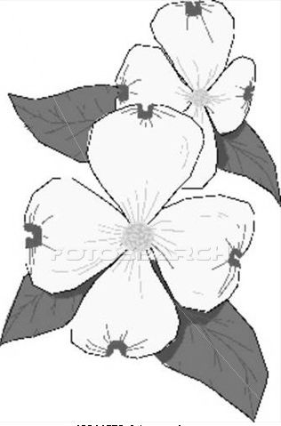
The flowers on the dogwood can be-either white, pink or red with four small petals per flower. On the tip or outer end of the petals is a dark spot with reddish coloring. In the center of the petals is a crown like formation. For this reason, many people identify the dogwood flower with the crucifixion of the Christ. The foliage or leaves on the dogwood are deciduous broadleaf meaning that the leaves are broad and shed annually.
Dogwoods grow well in zones 5 to 8 and need partial shade. Many people plant the dogwood as a stand-alone tree, but place it on the Northeast side of the home rather than on the south or southwest side of the house. Dogwoods need plenty of water especially after planting. To keep your dogwood beautiful, you should water it well when the leaves begin to look droopy like they are just beginning to wilt. A well-established dogwood will survive a drought reasonably well. The soil that you plant your dogwood tree in should have a pH range of 3.7 to 6.5, should be sandy, loamy or soil having some clay. Acidic soil works the best for your dogwood tree.
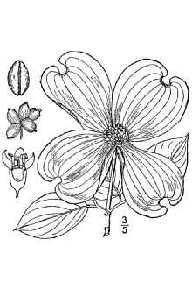
Trees from the wild should not be transplanted into your yard. Some wild dogwood trees have fungus, diseases or insect problems. The dogwood tree is susceptible to borers, anthracnose and flower and leaf spots. You should be careful when using lawnmowers and string trimmers around your dogwood.
Some types of dogwood trees are the Flowering Dogwood, the Kousa Dogwood and the Pagoda Dogwood. Of the Flowering Dogwood, there several different kinds: the Apple Blossom which has pink flowers, the Cherokee Chief which has red flowers, and the White Cloud which has soft white flowers.

Mt. Washington Arboretum

by Wil S. Hylton
Mike Sherlock saw trees. They weren’t there, but he saw them anyway. He stood on the floodplain of Western Run stream, a few blocks from his house, watching bulldozers shred the landscape. It was the summer of 1998, and for 20 years, the streambed had been an impenetrable thicket of brambles and poison ivy. But now the city had come to install a new sewer line. They plowed through the vines. They bowled over the brush. They hauled away old chunks of concrete as large as refrigerators. And Mike Sherlock squinted his eyes, imagining something beautiful to come.
These days, you can still find Sherlock on that floodplain almost any weekend morning, lugging one-gallon pots of wildflowers, or pushing an overloaded wheelbarrow of mulch, with a tireless enthusiasm that belies his 69 years. He is a tall man, 6’ 2”, with broad shoulders, a graying beard, and glasses that look hard to break. When a visitor comes, he stops to chat. “People thought I was crazy at first,” he says with a laugh. “The soil is thin. There’s a high clay content. When it rains, the water just sits on the ground. It’s not the easiest place to plant!”
Nothing about the project was easy: Securing permission to care for the land, winning grants to buy native trees like black gum, ironwood, and red maple, or finding time away from his practice as a pediatrician to nurture the fledging garden to life. But after a decade, no one would call Sherlock’s idea crazy. From the wrought-iron arch that announces the entrance of the “Mt. Washington Arboretum,” a cobblestone path sweeps the visitor into a verdant urban forest, pausing under a pergola where Sherlock holds seminars on landscape design in the summer, then winding along the edge of a bog garden, past a series of rain-catchments towers, and arriving finally at a stone council ring, built with a grant from the TKF foundation.
From mid-March, when thousands of daffodils light up the landscape, until late November, when the last scarlet leaves cast a sunset glow through barren wintry branches, the Mt. Washington Arboretum hums with visitors, volunteers, and wildlife – a vision of beauty come to life.

STONY RUN-They call it “Stony Fun.”
Every weekend since mid-October, the residents of Tuxedo Park have been coming together for a few hours to keep their section of Stony Run clean. With help from Friends School, the environmental club at Roland Park middle, and Charlie Murphy of TreeBaltimore, residents have removed hundreds of pounds of trash and debris, and several dump trucks of invasive brush, while clearing critical sections of the banks and floodplain for a planting drive in the spring. To help out, just stop by the trailhead on the end of Deepdene Road any Sunday afternoon at 2 pm. Tools and gloves are usually on site, but if you have your own, even better!

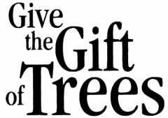
by Russ Moss
The next time you are faced with choosing a gift to acknowledge a holiday, birthday, anniversary or express condolence, consider the gift of a tree. A tree is the ultimate gift that keeps on giving!
For a really special holiday celebration consider planting a family tree. Each family member could bring memorabilia to add to a time capsule at the planting. Think of the infinite pleasure this living gift will bring in the coming years. The leaves and flowers will put on a show for each season. Birds will come with their nests and songs. Children will play and picnics will be enjoyed in the leafy shade.
As welcome as roses are on Valentines, anniversaries and other special days, cut flowers will last only a few days. A tree planted to honor a love one can last a lifetime and serve as a memorial.
Take another look at your gift list and consider giving a tree. A tree gift can be as flexible as your imagination. For more information about tree planting and time capsules visit the Baltimore City Forestry Board at http://www.baltimorecityforestryboard.org/

Big Trees
by Amanda Cunningham
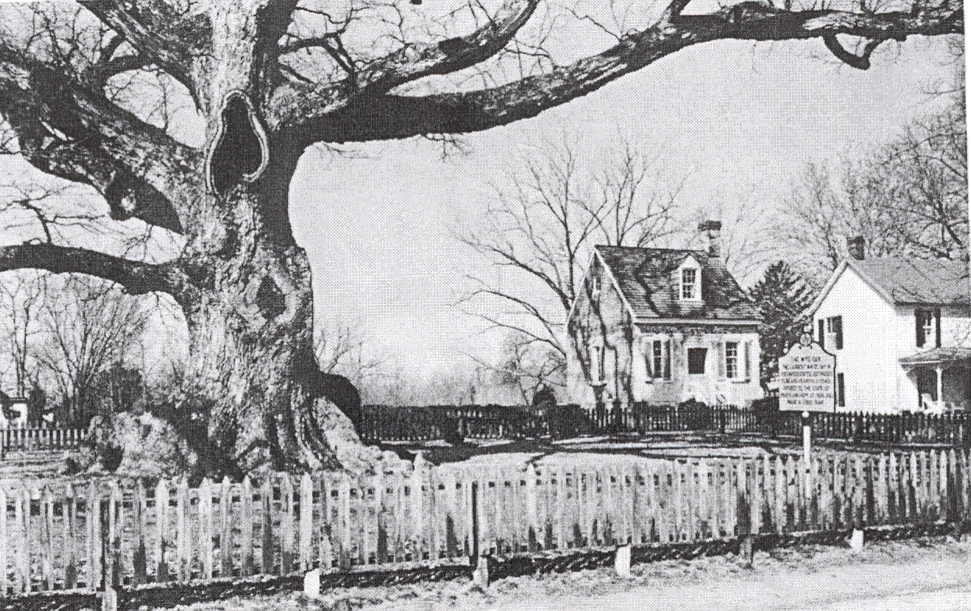
In 2010, the Baltimore City contingent of the Maryland Big Tree Program (MBTP) gained a fancy new tool to measure big trees and we succeeded in posting six state champion trees. The measuring tool, a laser hypsometer, now replaces the clinometer as the favored device for determining a tree’s height. We can thank John Bennett, Cecil County resident and volunteer leader of the MPTP for petitioning to the Maryland Department of Natural Resources (DNR), Forest Service on our behalf. Many thanks also go to Wayne Merkel, the Central Region DNR Forest Service Manager, who at John’s urging, allowed for the funding of the equipment for our use.
Tree measuring goes faster with the laser hypsometer. No need to measure out 100’ from each tree, and then take a reading, as you do with a clinometer. All you need to do with the hypsometer, is stand in a good spot to view the whole tree, take a series of three ‘shots’ of the tree with the device, and record the digital read-out for the tree’s actual height. A tree’s height along with the circumference and average crown width are combined to arrive at a total number of points for each tree. Point totals are compared with those recorded by volunteers in other Maryland counties and the competition is tough!
Our work in 2010 yielded six city trees achieving Maryland State Champion status. Five of these are located in city parks and one is growing on private property. Below is the list:

Balsam Fir, Abies Balsamea – In northeast Baltimore’s Clifton Park, near the Clifton Park Mansion on St. Lo Drive. Circumference: 8’ 5”; Height: 71.5’; And Average Crown Width: 42.5’. Total Points: 183.0

Overcup Oak, Quercus lyrata – Druid Hill Park, across from the entrance to Red Rd near St. Paul’s Cemetery. Circumference: Feet: 8’ 8”; Height: 53’; and Average Crown Width: 55’ 5”. Total Points: 171.0

Umbrella Magnolia, Magnolia tripetala - Gwynns Falls/Leakin Park, 1920 Eagle Drive, on east side of the driving loop near a picnic pavilion. Circumference: 1’ 8”; Height: 33’; and Average Crown Width: 24.85’. Total Points: 59.0

Bur Oak Bur, Quercus macrocarpa - Maryland Zoo at the African exhibit, next to the aviary. Circumference: 11’ 4”; Height: 87’; and Average Crown Width: 87’. Total Points: 245

Oak, English, Quercus robur – Druid Hill Park, near the 9th hole of the Frisbee Golf Course. Circumference: 13’ 7”; Height: 60’; and Average Crown Width: 83.5’. Total Points: 244.0

Bigleaf Magnolia, Magnolia macrophylla – located in the front yard of a private residence on Bellemore Road in the Poplar Hill neighborhood. Circumference: 7’ 6”; Height: 70’; and Average Crown Width: 56’. Total Points: 174.0
Many thanks to everyone who helped with the scouting, measuring, and documenting of our new champions in 2010. We look forward to another year of discovering Baltimore’s Big Trees! For more information on eligible species, visit American Forests at www.americanforests.org.

Summer Opportunity:
Natural Resources Career Conference
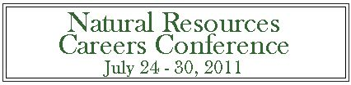
Beat Baltimore's heat! The Natural Resources Career Conference for high school students runs Sunday, July 24 through Saturday, July 30 at the Hickory Environmental Education Center, in cooperation with Allegany College in Garrett County. Join high school students from across the state for seven days of “green careers” education and great outdoors fun. You will sleep in cabins in leafy western Maryland and swim in a nearby lake.
Natural resources professionals and dedicated volunteers have developed the extensive curriculum for this week-long conference. Traditional forestry is at the core of NRCC’s educational experience, with inclusion of GIS and GPS technology and other tools of the trade. Urban Forestry and Watershed Ecology are also emphasized. This co-educational camp provides an opportunity for high schoolers interested in the out-of-doors to mentor with industry professionals and develop contacts that could lead to future employment in the field of natural resources.
Students who have reached age 16 by the first day of NRCC week can choose to earn two college credits from Allegany College of Maryland. College counseling night is always a favorite evening, while by day kids are in the field learning about conservation, wildlife issues, fisheries practices and watershed management.
Tuition assistance for NRCC week is available from the Baltimore City Forestry Board. City students should visit the NRCC website for information and an online application:
http://www.marylandforestryboards.org/nrcc.cfm or call Sandy Sparks at 410-243-2156.

Be a Good Neighbor,
Plant Wisely near Power Lines.

To minimize power outages in your neighborhood, BGE permits the planting of understory trees and shrubs under or near local/residential distribution power lines as follows:
• Hedges and screens, generally 6 to 15’ tall – allowed under/near power lines
• Shrubs and Trees generally less than 25’ tall – allowed under/near power lines
• Plant trees that will grow taller than 25’ at a distance away from power lines that is equal to or more than the expected mature height of the tree.
BGE recommends that property owners not plant any trees or shrubs within 10’ of any pole that has equipment mounted on it. If a customer has questions as to whether a pole contains electrical equipment, they can inquire by calling BGE at 410-685-0123 or 1-800-685- 0123. For more information, visit BGE’s website to view “Right Tree” and “Right Place” resources (go to www.bge.com, select “Energy Safety,” then “Tree Care,” then “I want to plant trees.” This includes information about BGE’s $100 per tree reimbursement program for the replacement of any tree greater than 8” in diameter measured at 4½’ above ground level. In addition to plants listed on BGE’s “Right Tree” materials, plants listed here that are less than 25’ tall are also eligible.
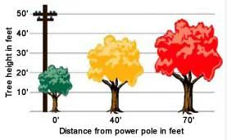
The Baltimore City Forestry Board encourages residents to use native plants. Native plants enhance habitat for wildlife and promote the preservation of Maryland’s natural heritage and avoiding use of exotic, invasive plants.
Native plants: This list of understory trees and shrubs presents a sample of native plants that meet BGE requirements for planting under or near power lines. Plants listed meet maximum height restrictions and are native to the Chesapeake Bay Watershed. Plants requiring full shade or are locally rare are excluded. Plants that are especially valuable to wildlife are identified.
For additional information about these plants, including characteristics, growing conditions, habitat, native habitat range, wildlife value, and additional information, view or download Native Plants for Wildlife Habitat and Conservation

Landscaping: Chesapeake Bay Watershed (see http://www.nps.gov/plants/pubs/Chesapeake/toc.htm
Finding native plants: Visit the Maryland Native Plant Society’s website at www.mdflora.org for information on native plants and local nurseries.
Avoiding invasive plants: Plants that are especially problematic for Maryland are listed on The Maryland Invasive Species Council’s site, http://www.mdinvasivesp.org/list_terrestrial_plants.html.
Planting instructions: Visit www.arborday.org for videos showing how to plant trees.
Plants that improve air quality: Homeowners interested in planting trees to improve air quality can go to http://www.itreetools.org/treecalculator/ to view the benefits of various species of trees.

Festivals and Special Events

Supported by the Board
EcoFestival, April 17th. Location: Druid Hill Park by the Reservoir. Baltimore Green Week kicks off with an EcoFestival as a celebration of our regional environment. Attendees will find fun family events and resources that promote sustainable living. Held in Druid Hill Park, near the Woodberry light rail stop, bus lines and Jones Falls trail, the EcoFestival will include workshops, demonstrations, vendors with sustainable products, healthy food, music and art. http://baltimoregreenweek.org/page.php?id=346

Cylburn Market Day, Saturday, May 7, a popular annual event in Baltimore. Parking may be limited owing to major construction on the grounds. http://www.cylburnassociation.org/

Baltimore Herb Festival, Saturday, May 28. 10 to 4, $5. Admission. Held in Leakin Park 1900 Eagle Drive Baltimore, MD 21207. Herbs, vegetable seedlings, garden ornaments and small native trees from the Baltimore City Forestry Board. http://www.baltimoreherbfestival.com/

Maryland State Fair: Aug 26–Sep. 05.
Timonium, Admission charges vary.

The Baltimore City Forest Conservancy District Board
is composed of individuals who serve voluntarily to promote the expansion and nurture of the urban canopy, so as to improve the health and welfare of Baltimore's residents.
All members of the Board are unpaid volunteers who work closely with state foresters. Members are formally appointed by the Director of the Maryland DNR-Forest Service on the recommendation of the chairman and members of the Board in consultation with our local DNR Forester. The board meets every third Tuesday of the month at the: Stieff Silver Building, 800 Wyman Dr. 21211.
The Board:
Sarah Lord (Chairman), Meredith Millspaugh (Vice Chairman), Tom Green (Treasurer), Patrick Holmes (Secretary), Russ Moss (Past Chairman), Ann Lundy (landscape designer), Gary Novak, Elspeth Wheeler, Sandy Sparks, Rebecca Feldberg (arborist), Bryon Salladin (arborist), Robbyn Lewis, Charles Ryan Murphy (arborist), Amanada Cunningham (arborist), Wil S. Hylton, Peter Duvall, Robert Black, (Editor & Webmaster), Gerard Moudry (Member Emeritus)

The Board’s Website:
http://www.baltimorecityforestryboard.org/

